To setup Kubernetes cluster on Ubuntu 24.04 with one control plane and 2 worker nodes.

Step 01: Update the Ubuntu 24.04 LTS system after deploying a new VM and installing OS version.
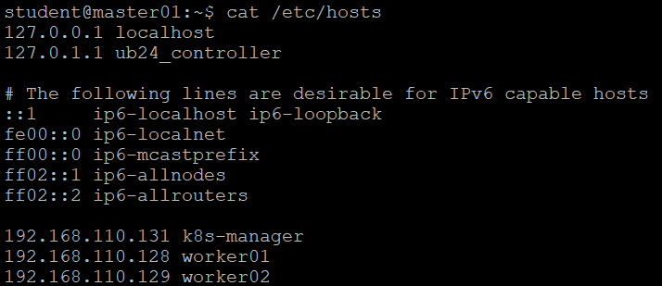
sudo apt update && sudo apt upgrade -y
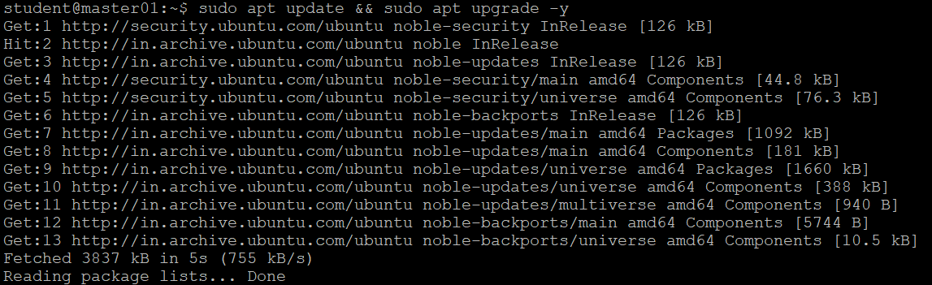
Disabled swap service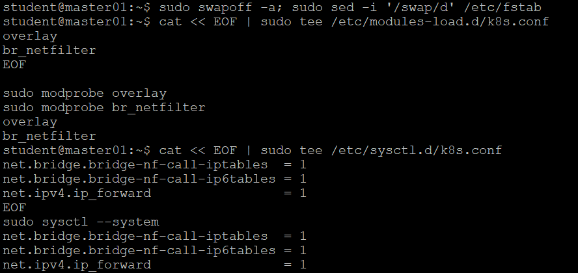
Load kernel modules:
cat << EOF | sudo tee /etc/modules-load.d/k8s.conf
overlay
br_netfilter
EOF
sudo modprobe overlay
sudo modprobe br_netfilter
Sysctl params
cat << EOF | sudo tee /etc/sysctl.d/k8s.conf
net.bridge.bridge-nf-call-iptables = 1
net.bridge.bridge-nf-call-ip6tables = 1
net.ipv4.ip_forward = 1
EOF
sudo sysctl –system

Install Container Runtime
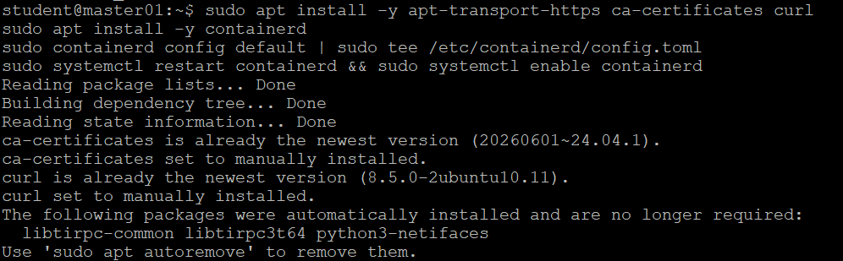
Add Kubernetes apt repository and Install kubeadm, kubelet, kubectl and conntrack
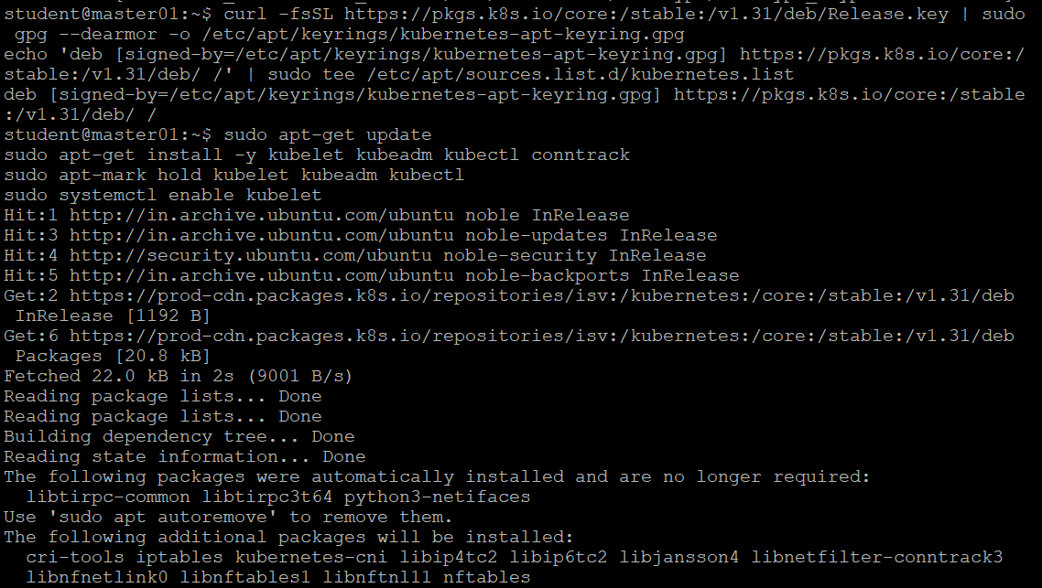
Initialize Control Plane (Run on manager node)
sudo kubeadm init --pod-network-cidr=10.244.0.0/16
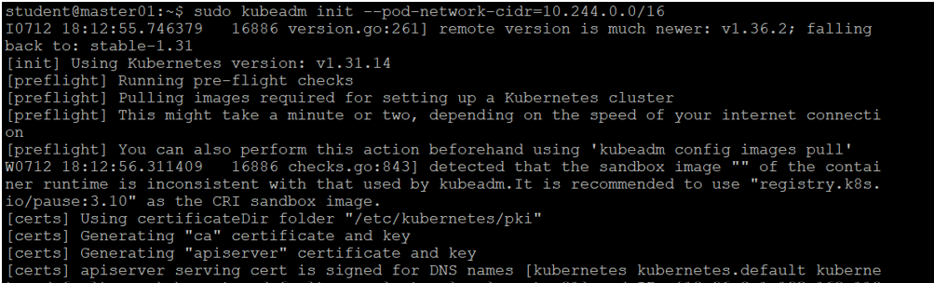

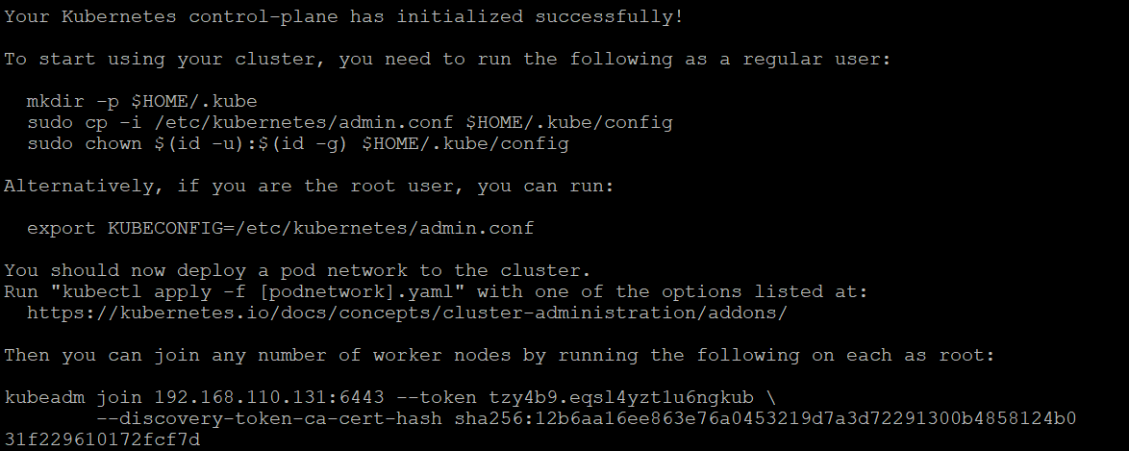
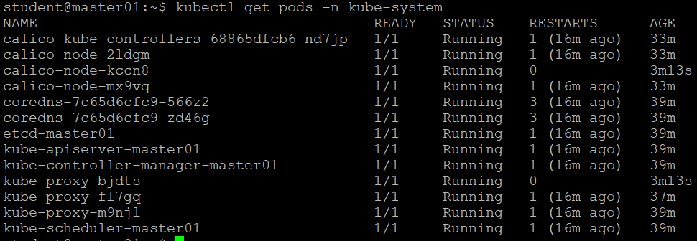
Joined worker01 and checked the status on manager node
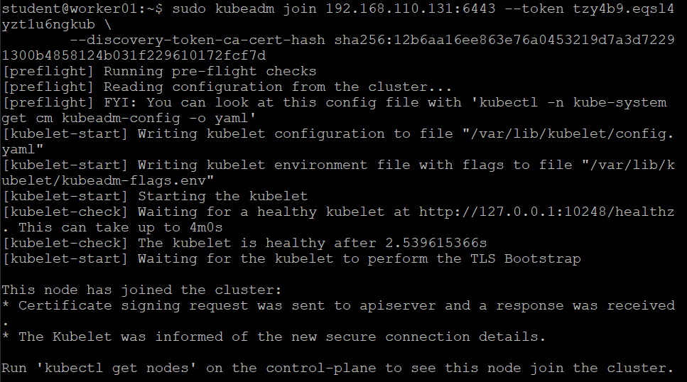
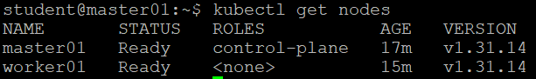
Joined worker02 and checked the status on manager node
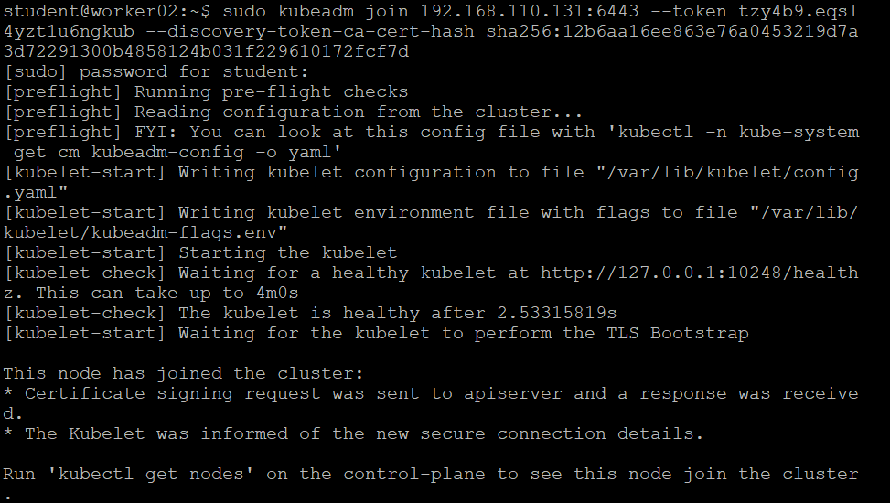
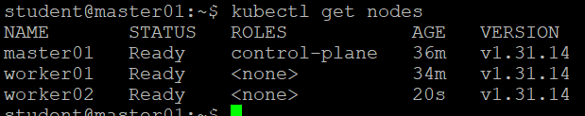
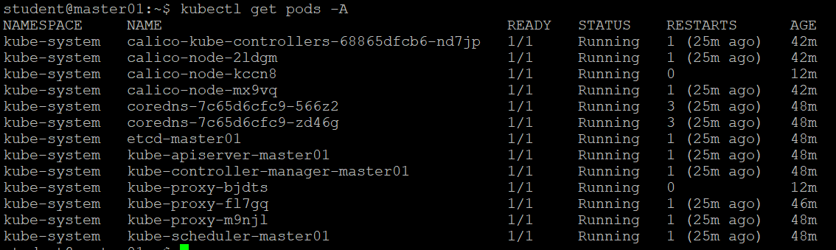
Deploy Nginx Application (Create a deployment)
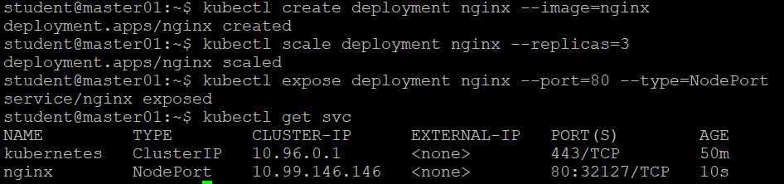
Verified the nginx service is running and accessible and exposed.
